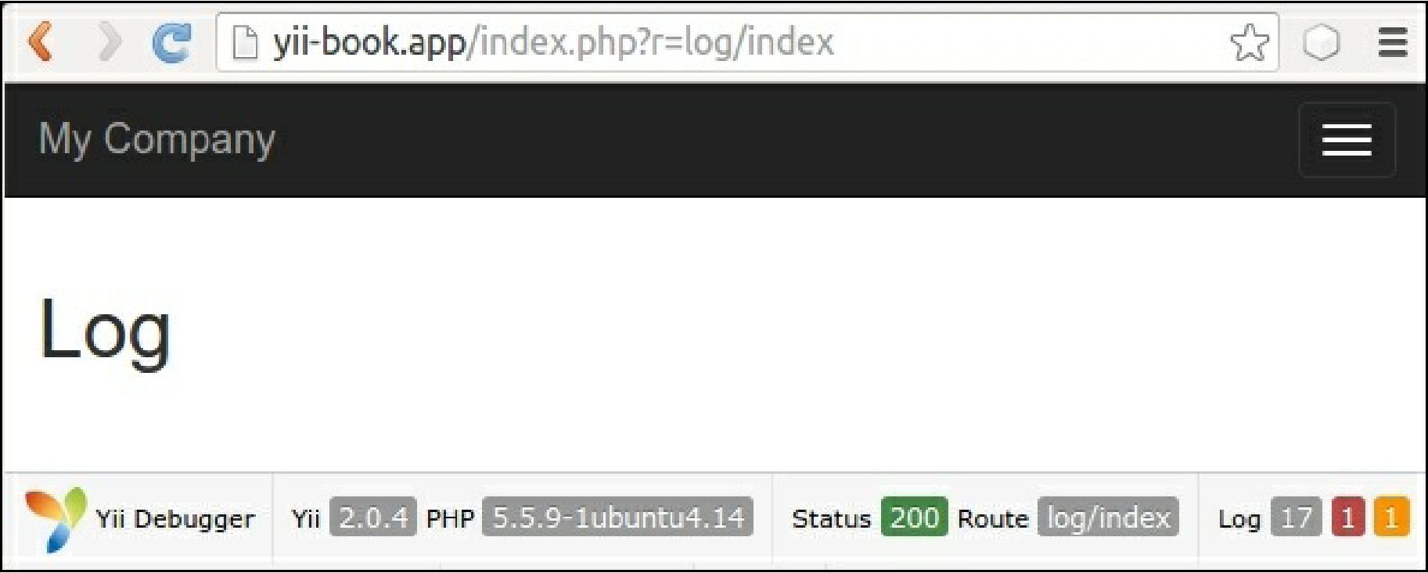

4. If you click on 17, you will see a web log similar to the one shown in the following screenshot:

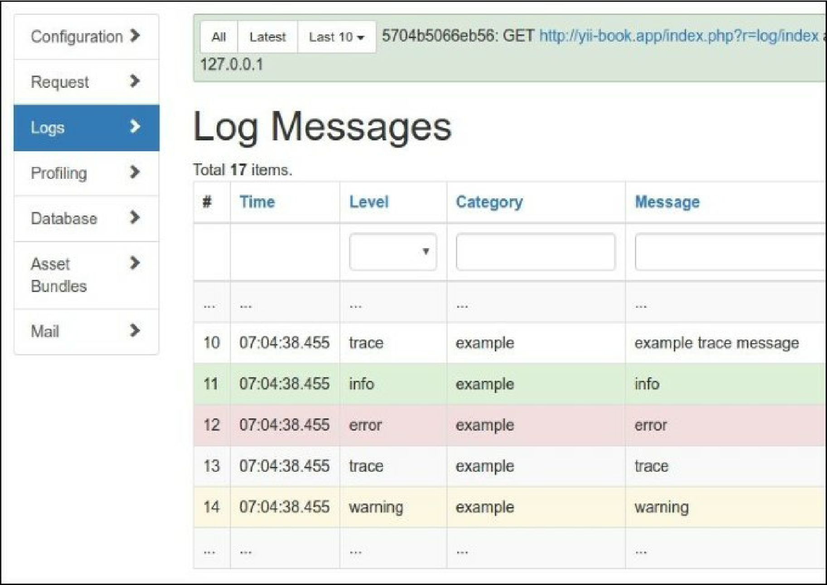

5. A log contains all the messages we have logged along with stack traces, timestamps, levels, and